DAA Practical 11 – Floyd-Warshall Algorithm
Design and Analysis of Algorithms

Aim
To implement the Floyd-Warshall Algorithm to find shortest paths between all pairs of vertices.

Floyd-Warshall Algorithm

1. Algorithm
Algorithm: Floyd-Warshall Algorithm

Aim:
To find the shortest path distance between every pair of vertices
in a weighted graph (All-Pairs Shortest Paths).

Input:
- Weighted graph with V vertices (may have directed edges)

Output:
- Distance matrix showing shortest distance from every vertex to every other vertex

Steps:
1. Start
2. Create a distance matrix dist[][]
3. Copy the graph weights into dist[][]
(use INF where there is no direct edge)
4. For k = 0 to V - 1, repeat steps 5 to 7
5. For i = 0 to V - 1, repeat steps 6 to 7
6. For j = 0 to V - 1, repeat step 7
7. If dist[i][k] + dist[k][j] < dist[i][j] then
dist[i][j] = dist[i][k] + dist[k][j]
8. Print the final distance matrix
9. Stop

Idea:
For every possible middle vertex k, check:
"Is going i -> k -> j shorter than the current i -> j path?"
If yes, update the distance.

Example Graph (4 vertices A B C D):
A->B:3, A->D:7
B->A:8, B->C:2
C->A:5, C->D:1
D->A:2

After Floyd-Warshall, shortest distances are computed for all pairs.
Example: A to C becomes 5 (A->B->C = 3+2)

Time Complexity: O(V^3)
Space Complexity: O(V^2)

Where V = number of vertices

2. Program Code (C Language)
File: Code/floyd_warshall.c
#include <stdio.h>

#define N 4
#define INF 9999

/*
Floyd-Warshall Algorithm
Find shortest path between every pair of vertices
*/

int main()
{
// graph with 4 vertices: 0=A, 1=B, 2=C, 3=D
// INF means no direct edge
int graph[N][N] = {
// A B C D
{ 0, 3, INF, 7 }, // A
{ 8, 0, 2, INF }, // B
{ 5, INF, 0, 1 }, // C
{ 2, INF, INF, 0 } // D
};

int dist[N][N];
char name[] = {'A', 'B', 'C', 'D'};
int i, j, k;

// copy graph into distance matrix
for (i = 0; i < N; i++)
for (j = 0; j < N; j++)
dist[i][j] = graph[i][j];

// try every middle vertex k
for (k = 0; k < N; k++)
{
for (i = 0; i < N; i++)
{
for (j = 0; j < N; j++)
{
// if path i->k->j is shorter, update
if (dist[i][k] + dist[k][j] < dist[i][j])
dist[i][j] = dist[i][k] + dist[k][j];
}
}
}

printf("Shortest distances between every pair:\n\n");
printf(" ");
for (j = 0; j < N; j++)
printf("%4c", name[j]);
printf("\n");

for (i = 0; i < N; i++)
{
printf("%c ", name[i]);
for (j = 0; j < N; j++)
{
if (dist[i][j] == INF)
printf("%4s", "INF");
else
printf("%4d", dist[i][j]);
}
printf("\n");
}

printf("\nTime Complexity: O(V^3)\n");
printf("Space Complexity: O(V^2)\n");

return 0;
}

3. Output
Sample program output:
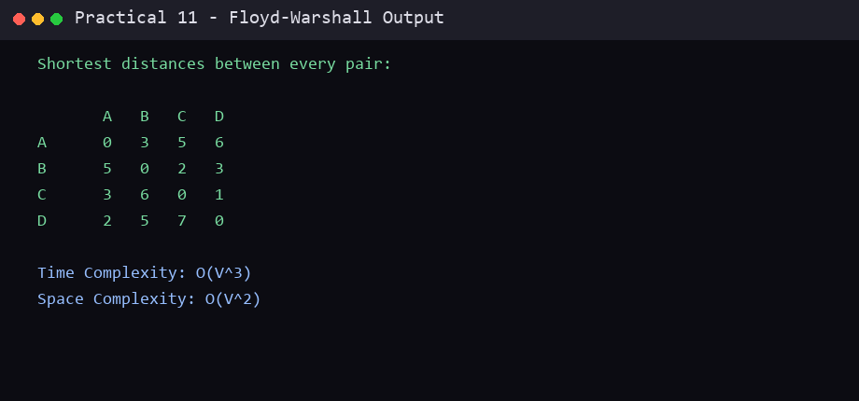

Conclusion
In this practical, the required algorithm was studied and implemented successfully in C. The algorithm, program code and sample output are recorded above. This practical helped in understanding the working and complexity of the technique used.
End of Practical 11

